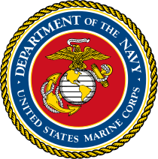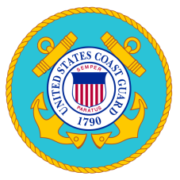
SHIPROCK CHAPTER VETERANS ORGANIZATION FINANCIAL ASSISTANCE CHECK LIST

Name: __________________________________________________________ Date: _____________________________
Branch Served: USMC COAST GUARD ARMY NAVY AIR FORCE
Veteran’s Information

Shiprock Chapter Veteran’s Assistance Form Social Security Card
Identification Card or Driver’s License DD-214
Voter’s Registration Card – Shiprock Chapter Certificate of Indian Blood (CIB)
Monthly Attendance/Sign In Sheet/Minutes (3) Quotations
Form W-9 Request for Taxpayer Identification Number and Certification
Chapter Responsibility:
RDP/FAF Chapter Resolution
Letter of Award Letter of Denial
Copy of Check
FOR SHIPROCK CHAPTER GOVERNMENT OF THE NAVAJO NATION USE ONLY:
Veteran’s Financial Assistance Requested: Approved Disapproved Amount: $ _________________

_______________________________________________________ _____________________________________________________
Commander SCVO Date Vice Commander SCVO Date

_______________________________________________________ ______________________________________________________
Secretary/Treasurer SCVO Date Community Service Coordinator Date

Date Check/Letter Picked Up

